Christmas Drinks
Thursday 30th November
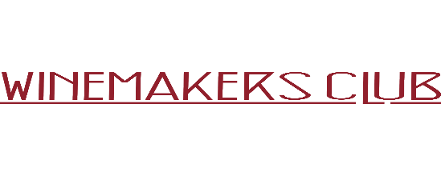
Farringdon
5pm onwards
Wines, Cheese & Charcuterie
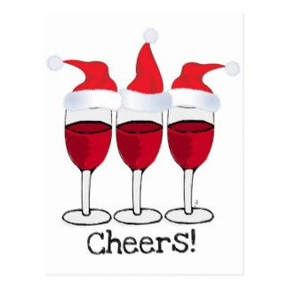
RSVP: Louise Oliver – admin@trads.uk
https://webinars.srevents.co.uk/webinars/trads/trads-christmas-drinks 