**Dentons Speakers**

Topic:

Commercial Property Management Case Law Update

Bryan Johnson

<https://www.dentons.com/en/bryan-johnston>

Philip Knight

<https://www.dentons.com/en/philip-knight>

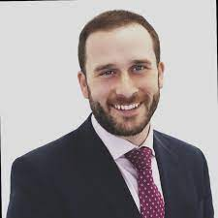

Daniel Lowen

<https://www.dentons.com/en/daniel-lowen>