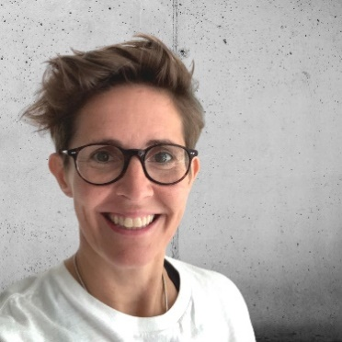
Title: Balance and Well-Being
Bio: Natalie is a certified coach, motivational speaker, qualified civil engineer and people enthusiast. Natalie spent 20+ years in retail building and construction before founding NMS Coaching where she now supports individuals and businesses with purpose, confidence, alignment, leadership, managing conflict and communication skills.
Natalie Miller-Snell (she/her)
Founder | Coach | Mentor

