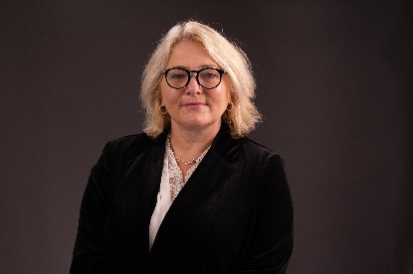

Polly Barnfield OBE helps businesses integrate AI into practical, measurable parts of their teams. As the Founder and CEO of Maybe\*, she has helped over 25,000 companies streamline operations and drive real impact with AI. Her core insight, The Big AI Secret, reveals that businesses don’t fail due to a lack of tools. They fail when tools don’t fit. This led to the creation of the patent-pending Maybe\* AI Agent Builder, which turns expertise, ideas, and problems into AI Agents that can be embedded directly into existing workflows. Previously, Polly founded Give as you Live, raising over £40 million for charity and earning an OBE for services to philanthropy.

Polly Barnfield, OBE

CEO Maybe\*

