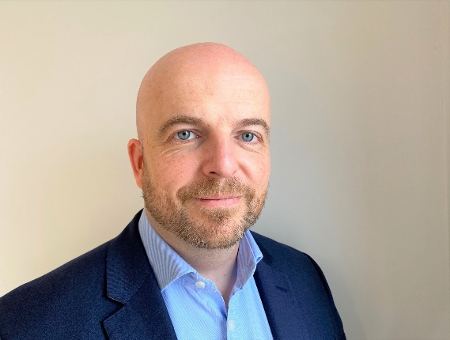

Ben Cox

Director – Asset Management

Ben joined the Sovereign Centros group in 2020 from intu Properties PLC where he is Asset Management Director for Metrocentre, one of the UK’s top shopping and leisure destinations.  
  
Ben spent 6 years at intu, firstly as Senior Asset Manager for intu Eldon Square and subsequently Metrocentre from 2018. His role involves overseeing leasing and asset management in addition to delivering development projects. Highlights have included the leasing of the entirety of the former Debenhams store to Frasers Group, delivering flagship stores for Zara, JD Sports, Sephora and H Beauty plus introducing a 40,000 sq ft NHS Community Diagnostic Centre in late 2024 as a major repurposing project.

Prior to intu, Ben was a Partner in Retail Agency at Sanderson Weatherall.

Ben is a qualified Chartered Surveyor and has 19 years post qualification experience.

