The Power of Presentation Skills in Business
Electronic communication has increased in the world with email, mobile phones and video calls. Nevertheless, people still buy from people.
If you want to connect with your audience whether one or many, then presentation skills will help you achieve that.
In this session Bob will demonstrate how presentation skills will help you pitch for business, build strong relationships with clients, and get your audience to take action.
He will cover how to prepare, structure and rehearse your business presentations for maximum impact.
If you have any questions about how to speak better in public, this is the session for you.

Bob Ferguson Bio
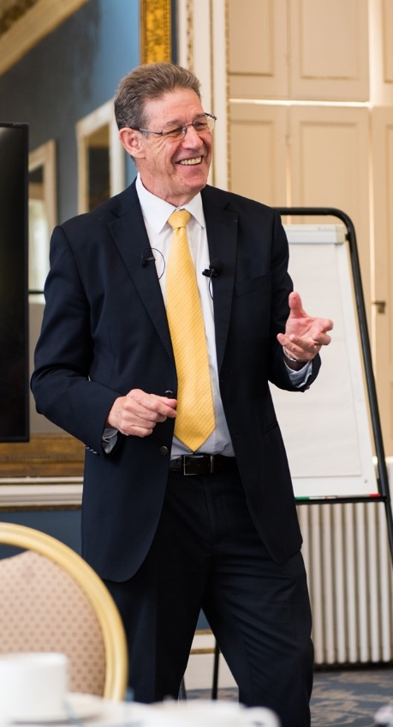
As an engineer Bob endured many bad presentations. Some of them were his!
Bob started his own development path to improve his public speaking. In the process he won three national speech championships and represented the UK & Ireland at the World Public Speaking Championship.
He also had 20-years’ experience in the space industry working on the European missions to Mars and Mercury during which he had to communicate complex concepts and information to a wide variety of audiences. He would often see his very bright colleague’s struggle to explain what’s in their head, to their peers and senior managers, and searched for ways they could improve.
The marriage of the two paths led to Bob’s passionate interest in the way that technical experts could communicate to get their message over with confidence, clarity, and impact so that they’re heard, understood and valued.

