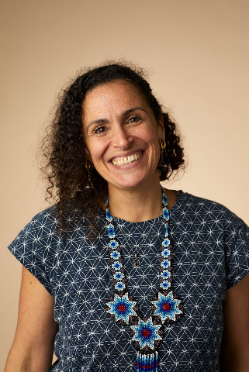

Ruth Andrade - Earth Care Strategy Lead for Lush Cosmetics

Born in the bioregion of the Brazilian Atlantic Moist Forests, Ruth grew up in a concrete jungle, witnessing first hand the destruction of the natural environment. This prompted an early interest in environmental issues, nurtured a deep love for the rainforest and fueled great passion for driving change. She considers herself a systems activist, identifying key nodal interventions in systems to support the transition to regenerative cultures. She has been co-creating Lush’s environmental strategy since 2004 and supports the business to leave the world Lusher than we found it. Ruth has a masters in Advanced Environmental and Energy Studies. She is a trustee and co-founder of Re.Alliance, a collective of practitioners bringing regenerative design to the humanitarian and development sectors, a co-creator of Regenerosity, an initiative with a mission to flow resources to grassroots regenerative projects.

