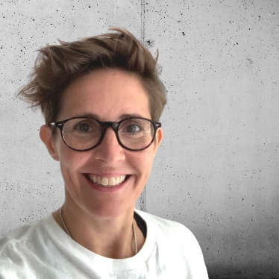
Title: Balance and Well-Being
Description: Do you ever find yourself uttering the words, "I'm crazy busy", "I don't have time to pause / for this.", "I feel overwhelmed." If so, please join Natalie Miller-Snell for 60 mins of group coaching as we explore how to pause, find balance and ensure we are checking in with our well-being, in order to be our most effective and productive selves.
Bio: Natalie is a certified coach, motivational speaker, qualified civil engineer and people enthusiast. Natalie spent 20+ years in retail building and construction before founding NMS Coaching where she now supports individuals and businesses with purpose, confidence, alignment, leadership, managing conflict and communication skills.
Natalie Miller-Snell (she/her)
Founder | Coach | Mentor

