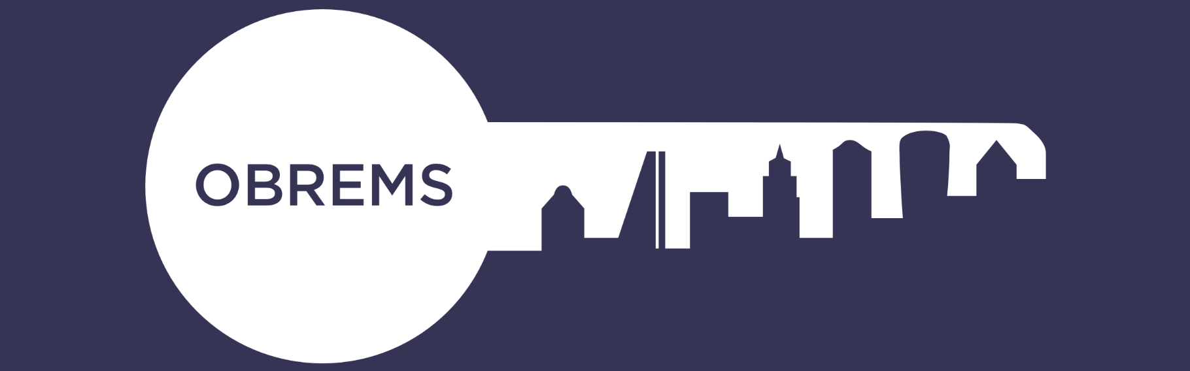

Obrems May Ball – Sponsorship Opportunities
IOD, 116 Pall Mall, St James’s, London SW1Y 5ED
Wednesday 11th May 2022 6:30pm – Midnight

Sponsorship Opportunity | Price | Additional Information
Core Sponsor – Gold | £3500 | - Full page advert  - Logo on all screen slides  - Logo on promotional marketing email and social media posts  - Logo on event E-tickets  - Logo in programme & on front cover.  - Branded drinks table at pre-dinner drinks
Core Sponsor – Silver | £2500 | - Half page advert  - Logo on screens  - Logo on promotional marketing email and social media posts  - Logo in programme.
Table Numbers | £850.00 | 25 laminated table numbers to be provided by the sponsor
Table Item (mints, pens, coasters, etc.) | £750.00 | 250 table items to be provided by the sponsor in addition to the sponsorship price
Auction | £1000.00 | Logo in programme aside all auction lots
Raffle | £1000.00 | Logo in programme aside all raffle items
Welcome Drinks Reception | £2,000.00 | Branded banner in Pre-Drinks area and logo in programme and on e-ticket
After Drinks Reception | £1,000.00 | Branded banner in After Drinks area and logo in programme and on e-ticket
Logo Promotion | £350.00 | Logo in programme & on screens
Heads & Tails | £1,000.00 | Logo on Heads & Tails envelopes and on screens and on e-ticket Winners prize to be donated by sponsor in addition to the sponsorship cost
Half Page Advert in Programme | £500.00 | Artwork to be supplied by sponsor
Full Page Advert in Programme | £1,000.00 | Artwork to be supplied by sponsor
Back Cover of Programme | £1,250.00 | Artwork to be supplied by sponsor

If you are interested in any of these sponsorship opportunities, please email louise@srevents.co.uk or call 01799 544905

