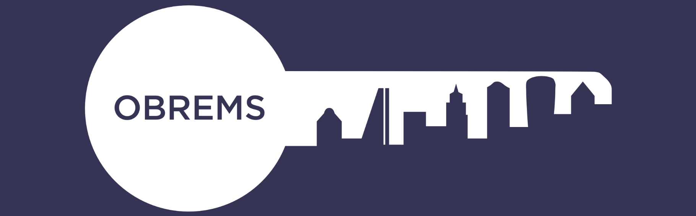

Obrems May Ball – Sponsorship Opportunities
IOD, 116 Pall Mall, St James’s, London SW1Y 5ED
Wednesday 11th May 2022 6:30pm – Midnight

Sponsorship Opportunity | Price | Additional Information
Core Sponsor – Silver | £2,500 | - Half page advert  - Logo on screens  - Logo on promotional marketing email and social media posts  - Logo in programme.
Core Sponsor – Gold | £3,500 | - Full page advert  - Logo on all screen slides  - Logo on promotional marketing email and social media posts  - Logo on event E-tickets  - Logo in programme & on front cover.  - Branded drinks table at pre-dinner drinks

If you are interested in any of these sponsorship opportunities, please email: louise@srevents.co.uk or call 01799 544905

